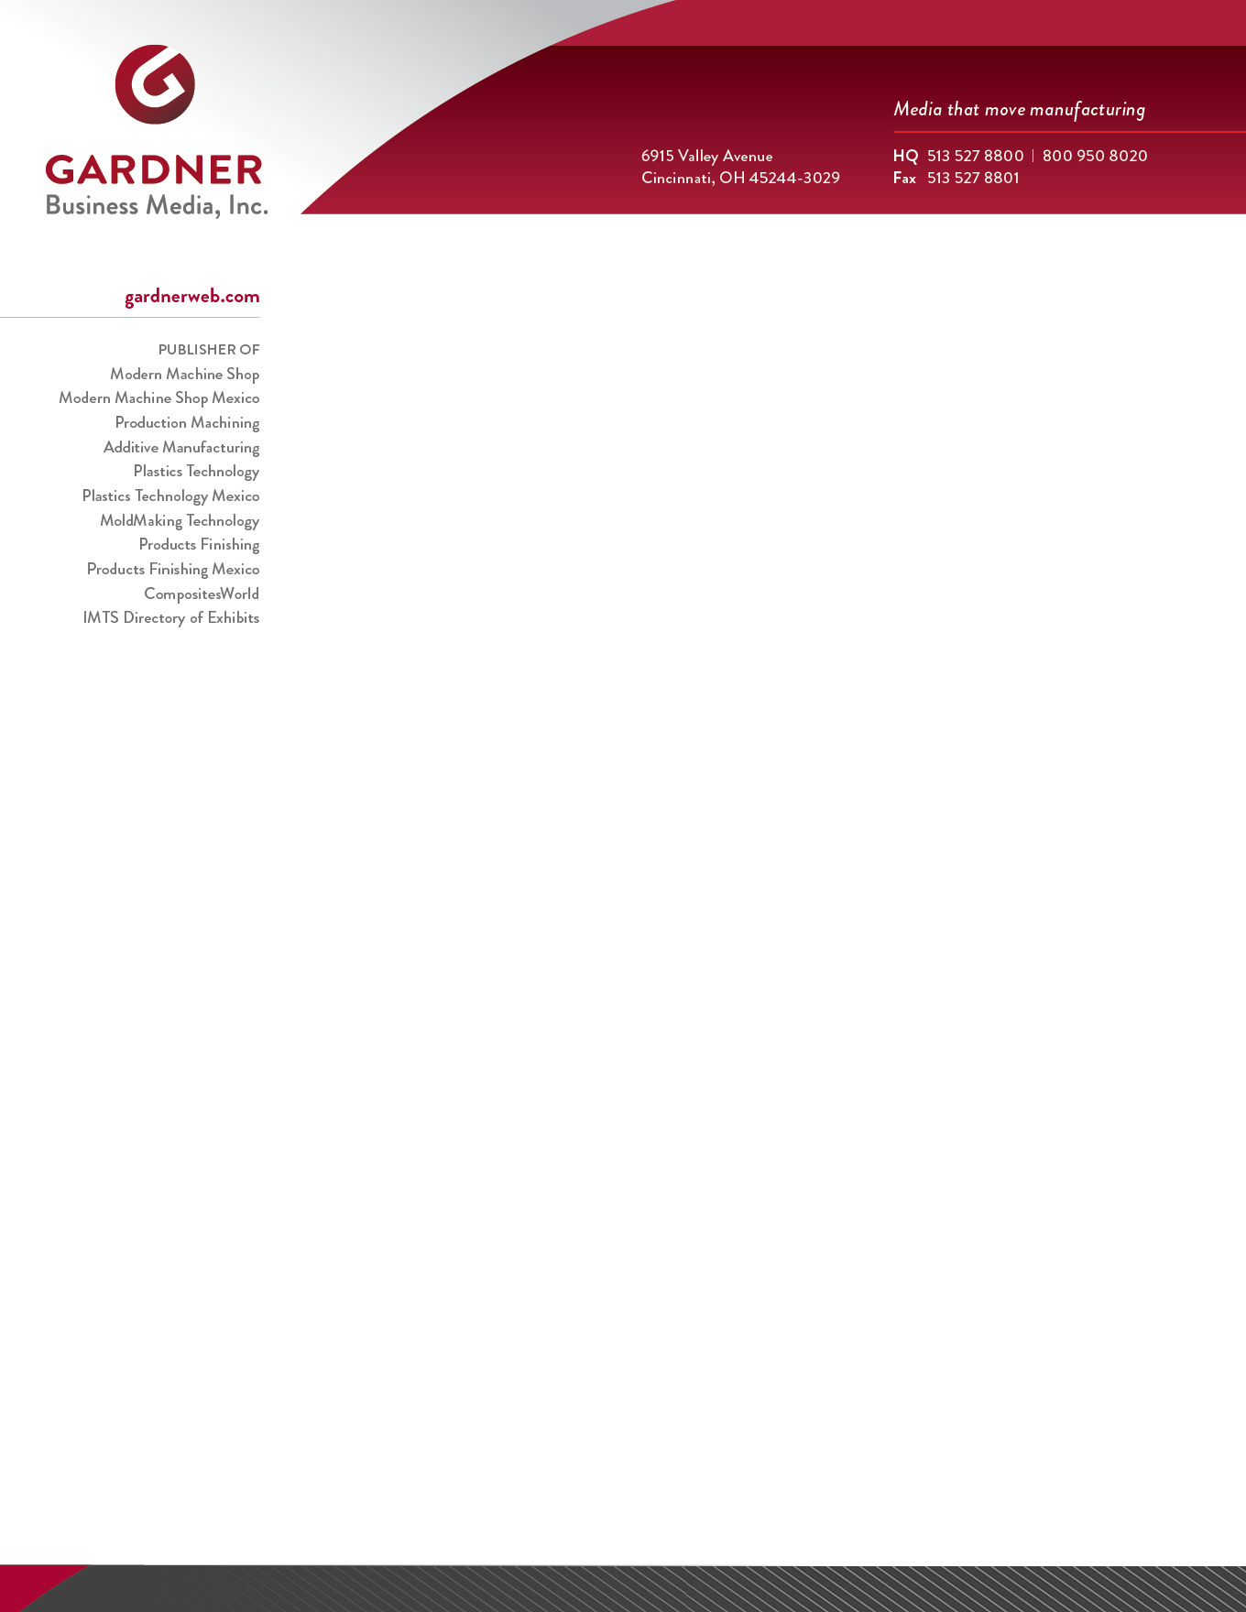

[Date], 2021

[Title/Name]
[Job Title]
[Company Name]
[Company Address]
Passport Number:
Passport Expiration Date:

Dear Attendee,
On behalf of Amerimold 2021, presented by Gardner Business Media, the parent company of Plastics Technology & MoldMaking Technology magazines, I am pleased to invite you to attend our industry-leading EXPO and educational trade show. Amerimold Expo 2021 will be held September 21-23 in Rosemont, Illinois USA, at the Donald E. Stephens Convention Center.

Manufacturing, like mold manufacturing and injection molding, have been an ESSENTIAL industry during the COVID-19 pandemic. The innovations and solutions that these men and women developed, manufactured, and distributed saved lives and helped bend the curve in the USA and around the world. We are excited to help your ESSENTIAL business and your essential employees to continue their WORK in developing their skills and evaluating new technology and solutions to continue the fight against COVID-19.
Amerimold 2021 is the mold manufacturing industry’s premier educational event showcasing the latest products and technologies for injection molding and mold manufacturing, from the design through delivery of injection molds, thermoforming molds and compression molds.
Attendees from around the globe will connect with exhibitors displaying a broad line of products, technologies, and services that include 3D printing equipment, mold materials, mold components, hot runner systems, cutting tools, inspection & measurement systems, mold maintenance & repair solutions, machine tools, software, automation and many more.
Register today! Come see why Amerimold 2021 is the best place to learn the latest market information and lessons to help identify appropriate technology products for your mold manufacturing needs.
To register for an Attendee badge please go to the Amerimold 2021 website after May 10, 2021: https://www.amerimoldexpo.com/
- Click on the red “REGISTER” button in the center of the page

For travel and hotel information please go to: https://www.amerimoldexpo.com/hotel-and-travel
(NOTE: Remember, you MUST mention Amerimold 2021 when making your hotel reservations to receive the discounted show rate.)
Please feel free to contact me if you have any questions or need any additional information.

Allison Kline Miller
Chief Events Officer
Amerimold 2021 Show Director
amiller@gardnerweb.com

